Indian Institute of Technology Kharagpur
Department of Humanities and Social Sciences

Assignment-I Full Marks: 20
Submission Timeline: 05/02/2022 (Saturday) 1:00pm
Subject No: HS20202/HS41002 Subject Name: Econometric Analysis I

Instructions: Answer all the questions. Submit the Answer Script within the given timeline in MS Teams only. Submission through email will not be considered.

- Comment on the following statements with justification/proof/empirical supports: 2×2=4

- The problem of multicollinearity is of both existence as well as severity.

Answer:

The problem of multicollinearity is of severity and NOT of existence. Any multiple regression model will have some degree of multicollinearity. However, when multicollinearity is severe, it is matter of serious concern.

- The goodness-of-fit of a bivariate regression model will not differ depending on whether we include or exclude the intercept.

Answer:

The goodness-of-fit of a bivariate regression model will differ depending on whether we include or exclude the intercept

For the model 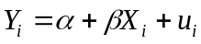, 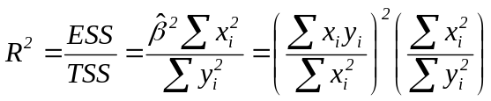
For the model 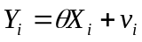, 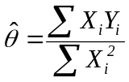
Hence, 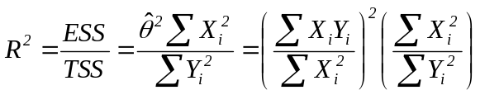

Why not
and 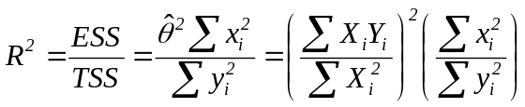

- Consider three uncorrelated variables 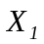, 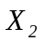 and 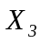 with each having the same standard deviation . Find out the correlation coefficient between 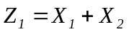 and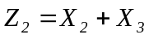. Derive the OLS estimator of the regression coefficient if 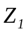is regressed on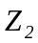.

Answer:

We have, or 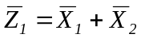
Similarly, 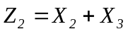 or 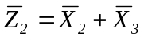
Further, 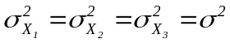
Hence, 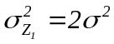 and 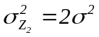
Hence, 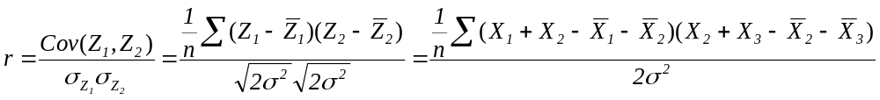
Or, 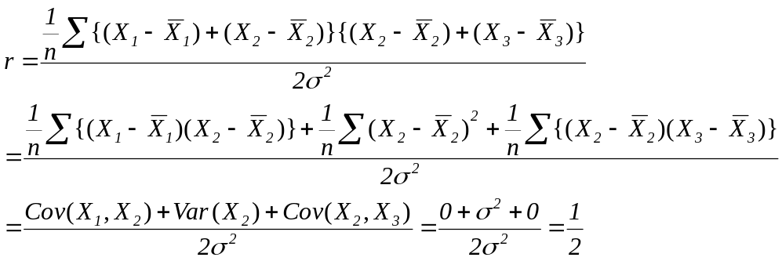

[As the variables , and are uncorrelated]

Regression Model: 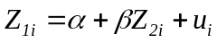

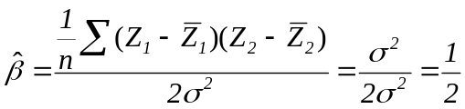

Alternative Proof: 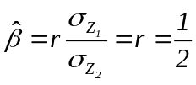
4
- Consider the following two models:

(a) 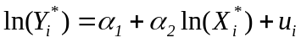with 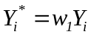 and 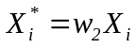; (b)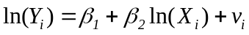
Examine how the OLS estimators of the regression coefficients and their standard errors differ between these two models. Will there be any difference in the value of 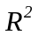?
Answer:

Consider the model: with and
Hence, 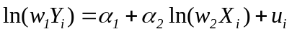
Or,
Or,
Or, 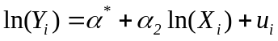 where 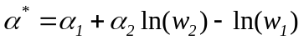 (1)
We have the other model (2)

Comparing (1) and (2) it can be said that the two models differ in respect of the intercept and the random disturbance term.

Hence, the two models will have the same OLS estimator of the slope coefficient by different intercept.

Further, there will be no difference in the value of as both the total sum of squares (TSS) and the explained sum of squares (ESS) will be same for the two models.

Similarly, since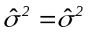, the standard error of the slope coefficient will be the same in the two models, though the standard error of the intercept will differ.
4
- Suppose you are interested to identify the factors that influence variations in inflows of industrial investment across the Indian states. Specify the regression model that can be estimated for this purpose. Discuss how the variables will be measured along with their expected impact on the dependent variable. What steps will you follow to estimate this model and interpret the regression results?

8

______________

